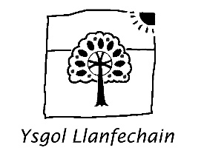
Llanfechain Church in Wales School

Ysgol Yr Eglwys Yng Nghymru Llanfechain
Llanfechain
Powys
SY22 6UQ

Telephone: 01691 828537
E.mail:office@llanfechain.powys.sch.uk

Executive Headteacher: Mrs Catherine Hart BEd(Hons) NPQH

15.5.24

Dear parents and carers,
Lockdown Drill THIS IS NOT REAL - IT IS A DRILL

Today we have held our second Lockdown Drill for all our staff and learners. This is to ensure that the processes we have in place are effective in the event of an emergency. We discussed why we might need such a drill with the children beforehand and cited reasons such as a wild animal on the playground, or a particularly extreme storm.

The scenario for today’s drill was if there was a threat outside and they were outside at playtime. The children were asked to go inside and sit quietly in their classrooms until the ‘danger’ had passed. As part of our response in activating our Lockdown Procedures we will contact parents to say that there is a lockdown situation at the school and to give instructions about collecting the children safely. This is the purpose of this letter. Today it is a drill – not an emergency.

If you have questions regarding this, or any other aspect of our safeguarding procedures, please feel free to contact myself, or Miss Mills.

Kind regards,

Catherine

